**Investigation of the acetaminophen in different fever and flu tablets**

*Nathan Quek, Yeoh Tian Huai, Justin Ang*

*School of Science and Technology, Singapore*

**Abstract**

Acetaminophen has been used as a pain relief drug for at least about half a century. Acetaminophen, being used so regularly, can also cause great harm as much as it causes great relief. As such, our research, which aims to measure the amount of acetaminophen in 7 different tablets and ensure that they are below the recommended amount, which is 500mg. To do so, we utilised spectrometry, which uses light to detect the concentration of acetaminophen. After research, there is evidence that the amount of acetaminophen in tablets are at a safe value, and that human life is not at threat. The results of this research can be used to catalogue levels of acetaminophen in tablets to better present such information. They can also be used to inform the public and increase awareness on the leathality of acetaminophen. Limitations and areas for further research are also discussed.

Key words: Acetaminophen, Tablets, Spectrometry, Drug

**Project Title: Investigation of the acetaminophen in different fever and flu tablets**

**1. INTRODUCTION:**

**1.1. Background information**

Acetaminophen, known more commonly as Panadol or Paracetamol, is a chemical commonly found in many different forms such as capsules, liquid, chewable or disintegrating tablets, and dissolving powders or granules. (U.S. Food and Drug Administration, 2022) This chemical is widely known to alleviate physical pain and a fever reducer, however an overdose could be fatal to the consumer.

As commonly used over-the-counter drug, the dosages inside the medications may not be optimal for everyone, or they may use fake advertising in their advertisements. Or worse, they may be sold counterfeit drugs. (Food and Drug Administration Philippines)

**1.2. Introduce the specific topic**

The recommended dosage for acetominorphen is 4000mg for a healthy adult. However, for most adults, it is recommended to not exceed 3000mg of acetominorphen per day (Harvard Health Publishing., 2020).

Yet, acetaminophen overdose is the second most common cause for liver transplantation globally and the most common cause in the US. It is responsible for 56000 A&E visits, 2600 hospitalisations and 500 deaths per year in the US alone.   
(Agrawal, S., & Khazaeni, B., 2022)

Thus, if we are able to investigate and find out the acetaminophen dosage in flu and fever tablets that people normally buy, we may be able to warn them to look at the dosage of acetaminophen, thus we may develop a tag that says this product’s dosage is suitable for people from ages X to Y after investigating the acetaminophen in these products, thus, ensuring that the consumer will be safe when they consume these products.

**1.3. Past research**

Acetaminophen can be absorbed rapidly from the gastrointestinal tract and a dose taken by a fasting subject reaches mean peak plasma concentration in 70 minutes. It has been demonstrated that this peak can be delayed to a mean of 160 minutes with administration of propantheline which slows gastric emptying.

Increasing concern was raised about the toxicity of nonprescription analgesics, but in normal use paracetamol exhibited a consistent safety profile. Its exemplary safety record was marred by the discovery in 1966 that a major overdose could be complicated by severe and sometimes fatal liver damage. (Prescott L. F. , 2000). In addition to this, only 38% of people could select the appropriate dosage of Panadol.

In recent years, it has come to light that some “companies” are manufacturing counterfeit products for Panadol and Paracetamol, which are commonly used. As such, we are testing for acetaminophen in various different companies (Food and Drug Administration Philippines).

**1.4. Conclude the Introduction**

**1.4.1 Specific objectives of the research**

Hence, we want to measure the amount of acetominophen in the 7 different tablet brands to ensure safety in consumption by the consumer and ensure they are out of harms way.

In order for it to be safe, the maximum amount of acetaminophen in a pill should not exceed the result in the following equation(4000mg/No. of doses in a 24 hour period), assuming a healthy adult individual. For children, the maximum amount of acetominophen should not exceed(15mg of acetominophen per Child’s weight in kg).

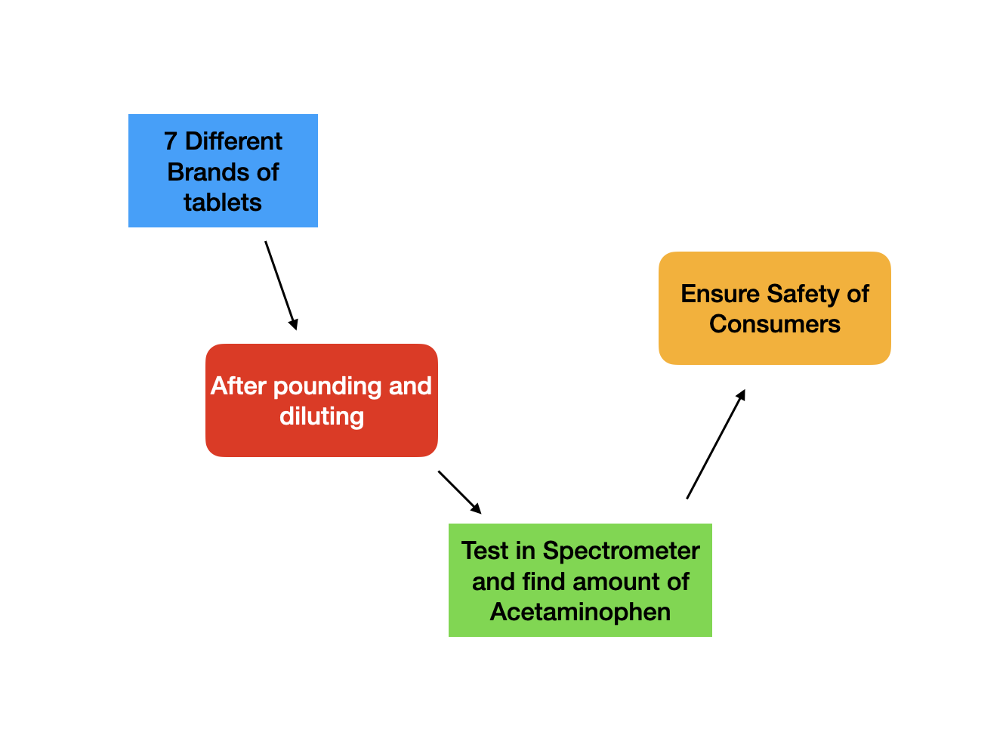

Fig 1.1 Experimentation Process

Thus, through spectrometry, we can find the amount of Acetominorphen in the Panadol tablets.

**1.4.2 Research Questions**

Is the acetaminophen level in different fever and flu tablets from different companies safe for consumption?

**1.4.3 Research Hypotheses**

We decided to test the following hypothesis:

H1: The amount of acetaminophen in the 7 different brands of tablets should have levels not exceeding 500 mg per tablet.

**1.4.3.1 Independent variable**

7 Different brands of tablets

**1.4.3.2 Dependent variable**

Amount of Acetaminophen in the Panadol/Tylenol/ Etc Tablets

**1.4.3.3 Controlled variables**

1. Using the same model of Spectrometer
2. Same duration of analysis
3. All are tablets
4. The sample mass to be mixed with distilled water is 100mg.

**2.    Method**

**2.1 Equipment list:**

* 7 Different brands of tablets with Acetaminophen
* 1 Mortar and Pestle
* 8 Cuvettes
* 1 Measuring Tube
* 1 SpectroVis Plus SVIS-PL
* 1 LabQuest 2 Datalogger
* 1 Rag
* 1 Bottle of Soap
* Distilled water
* A box of Sterile gloves
* 1 Clean Filtering flask with a Vacumm adapter
* 1 bag of Diatomaceous Earth(Celite)
* 14 pieces of Circular Filter Paper
* 1 Büchner Funnel
* 1 Bottle of Hydrochlocic Acid(50ml)
* 1 Bottle of Iron Chloride Solution(III)(5%)(50ml)
* 1 Bottle of Potassium Hexacyanofluride(III)(100g)
* 4 Beakers(A,B,C,D)

**2.2 Diagrams**

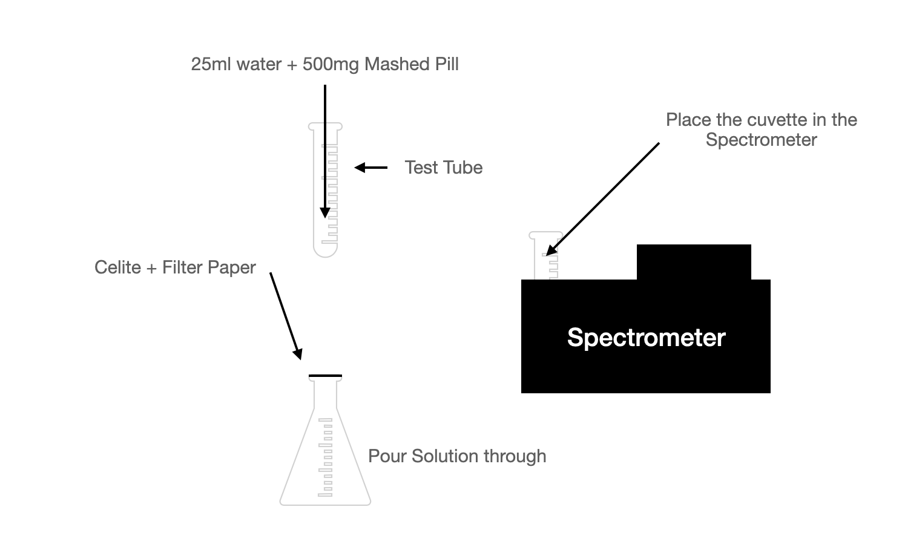

Figure 1.1: Experimental setup diagram

**2.3 Procedures: Detail all procedures and experimental design to be used for data collection**

**Preparation:**

1. Purchase 7 different brands of Panadol
2. Wear sterile gloves

**Cleaning of Equipment:**

1. Rinse and Wash the Mortar and Pastle with soap and distilled water.
2. Once soaped, rinse off the soap with distilled water.
3. After rinsing, ensure no soap is left on the Mortar and Pastle and use a piece of tissue to dry.
4. Place 1 tablet into the mortar and pestle and grind.
5. Ensure all of the tablet has been grinded into a fine powdery substance.
6. Measure 100mg of tablet powder and pour it into a beaker(A), and dilute with 250ml of distilled water,
7. Take a Buchner funnel hooked to a vacuum tube.
8. Place a piece of filter paper on the top of a Buchner funnel.
9. Open the bag of Diateomaceous Earth(Celite) and take ¾ tablespoon out.
10. Pour the Celite out of the spoon and spread it over the filter paper thinly.
11. Wet the celite using distilled water
12. Connect the Diaphram Pump to the Vaccum funnel.
13. Turn on the Diaphragm Pump.
14. Once the Buchner funnel is dry, turn off the Diaphragm pump.
15. Empty the contents of the Vaccum funnel into the drain.

**Experimentation:**

1. Place another piece of filter paper on top of the Buchner funnel.
2. Pour 50ml of the solution from the beaker(A) into the Buchner Funnel
3. Turn on the Diaphragm Pump and wait untill the Buchner Funnel drips dry.
4. After the solution in the Buchner Funnel drips dry, unhook the vacuum tube
5. After that, pour the solution out into a separate beaker(B).
6. Then, pour 25ml from beaker(B) into a 500ml measuring cylinder
7. Dilute the solution poured from beaker(B) by pouring in distilled water until it reaches the 500ml mark.
8. Then, pour out 25ml into another beaker(C).
9. Fill the beaker(C) with distilled water up till 250ml to dilute the solution.
10. Measure 10ml of the solution in beaker(C) and pour it into another beaker(D).
11. Wear eye goggles
12. Add 2-3 drops of Iron Chloride Solution(III) (5%) into the beaker(D).
13. Add 4g of Potassium Hexacyanoferrate(III) into the beaker(D) and mix well
14. Let the mixture sit for 10 minutes
15. After 10 minutes, pour 1ml Hydrochloric Acid into the beaker(D) and mix.
16. Pour it into the cuvette until the cuvette is approximately ¾ full.

**Testing:**

1. Place it into the spectrometer
2. Repeat steps 2-34 for each different Panadol brand.

**2.4 Data Analysis: Describe the procedures you will use to analyze the data / results.**

**36.** Tabulate the data and calculate the amount of acetaminophen as shown below(Rounded to 3 S.F.):

| **Sample/Reading** | **Reading 1**  **(In mg)** | **Reading 2(In mg)** | **Reading**  **(Average)**  **(In mg)** | **Standard Deviation**  **(3.S.F)** | **Error (3 S.F.)** |
| --- | --- | --- | --- | --- | --- |
| 1 (Panadol Optizorb) | 395 | 398 | 397 | 2.12 | 1.46 |
| 2 (Panadol Mini Caps) | 387 | 386 | 387 | 0.707 | 0.841 |
| 3 (Expired Paracil) | 379 | 376 | 378 | 2.12 | 1.46 |
| 4 (Progesic) | 381 | 387 | 384 | 4.24 | 2.06 |
| 5 (Tylenol) | 390 | 391 | 391 | 0.707 | 0.841 |
| 6 (Guardian Fever and Pain Relief | 346 | 345 | 346 | 0.707 | 0.841 |
| 7 (Non-Expired Paracil) | 410 | 411 | 411 | 0.707 | 0.841 |

**37. Plot a bar graph on the level of Acetaminophen in the different brands of tablets using Beer’s Law for concentration. This chart does not factor in error bars.**

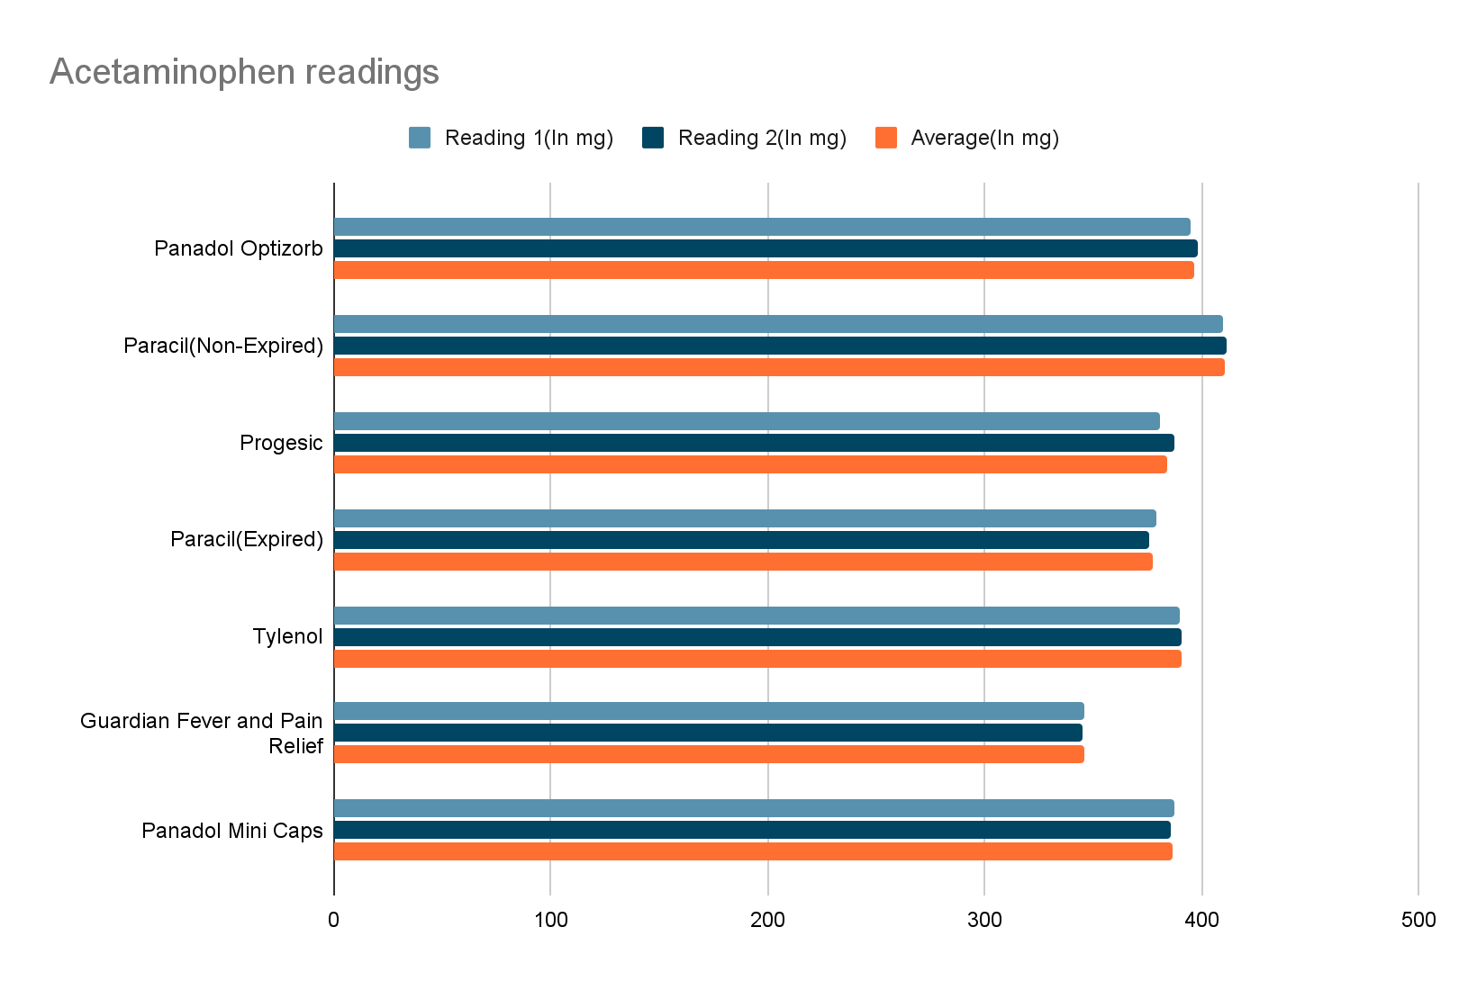

Figure 1.4: Bar Chart on the Level of Acetaminophen in the 7 different tablets.

**38. Find out if the acetaminophen level is ≤500 mg. Graph above should be the same or similar as the graph below.**

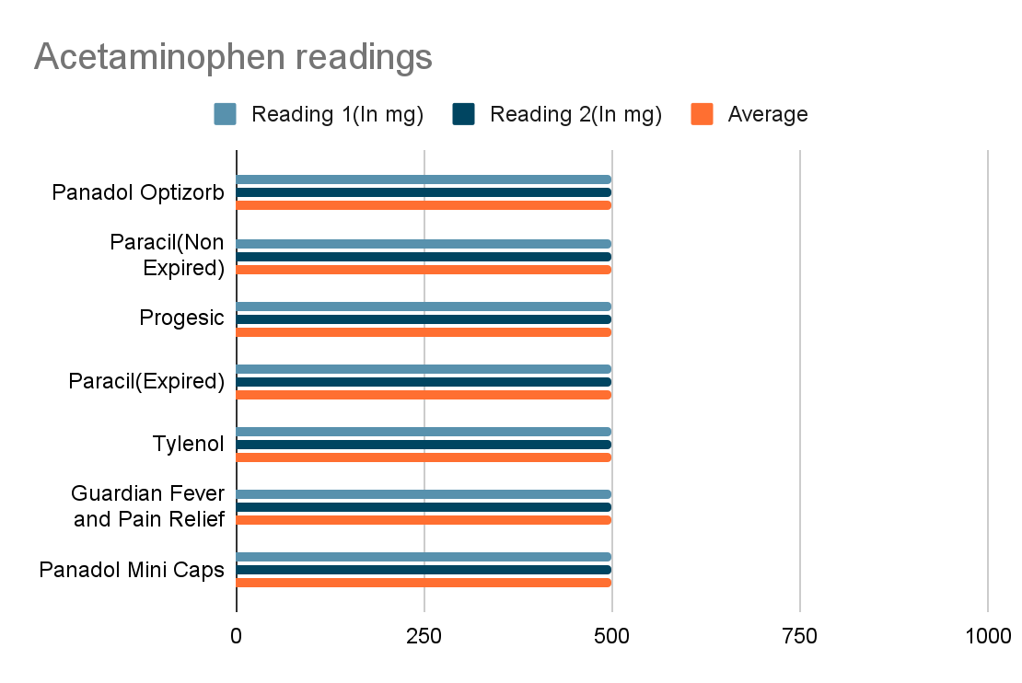

Figure 1.5: Hypothesised levels of Acetaminophen in the 7 different tablet brands

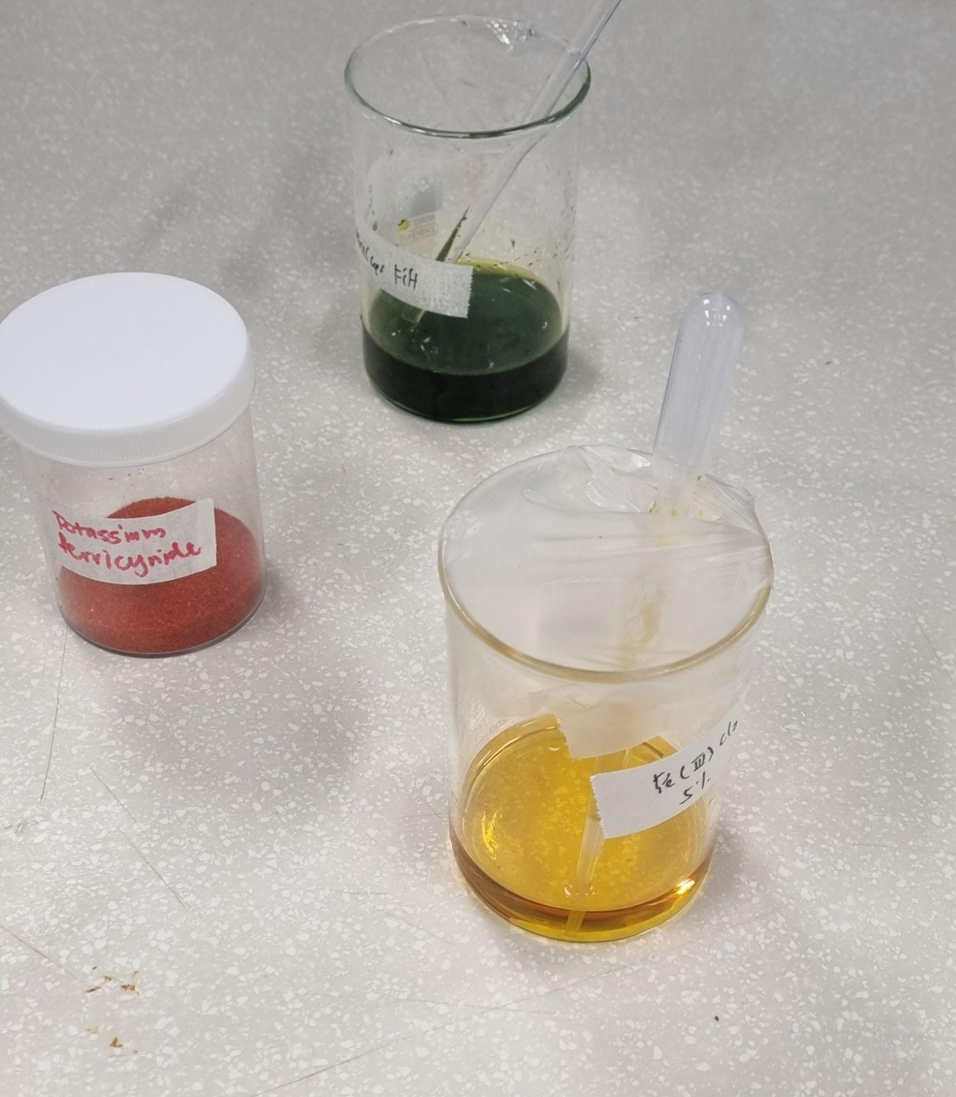

Figure 1.2: Experiment and Chemicals(Middle-left ground(Potassium Hexacyanoferrate(III)), Background(Experiment Sample), Foreground(Iron Chloride Solution(III)(5%))

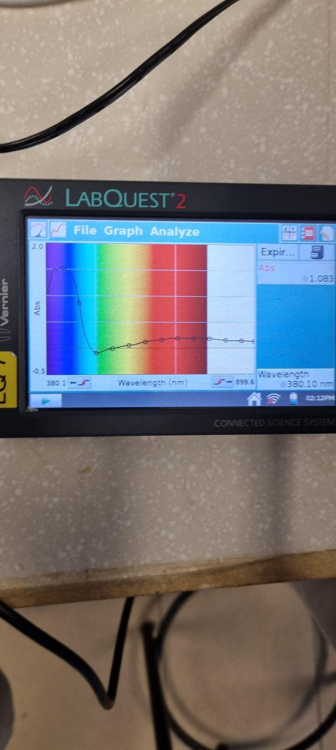

Fig 1.3: LabQuest 2 Datalogger

**4. Discussion**

**4.1 Key Findings, Comparison and Explanations**

    From the chart and the data collected, it is evident that our hypothesis H1 is valid. Across all the values, the amount collated is no more that 411mg per pill of 500mg. This is a safe value as the maximum value of 500mg*8 doses for 4000mg per day for an adult as a maximum. (Harvard Health Publishing, 2022).

However, this does not match with stated claims by the companies that write that each pill contains, which is 500mg of acetaminophen. Compared to our results for example, Panadol Mini Caps on their website(Medicines to Midnight), contains 500mg of acetaminophen per tablet. However, our research and findings show that Panadol Mini Caps, on average, has 387mg of acetaminophen per tablet. Such a discrepancy could be due to for example, equipment shortcomings, which will be discussed more later.

To come to this conclusion, we used Beer’s Law to calculate the convert the raw data in the form of Abs to concentration. After this, we reversed our steps of dilution to end up with the final amount calculated. Using the results, we can then compare against the expected results or against what the amount is stated on as per the ingredients list on the manufactures.

**4.2 Limitations and Recommendations**

Although this method of finding amount can be used, there are several limitations to it. As such, all findings in this research project should be taken with a pinch of salt. Firstly, our steps may not be a optimal one. Our steps were crafted with reference a RSC student document(RSC Education) and edited to suit our needs and time constraints. This may mean that steps may not be in a optimal order and may affect our results. As such, we recommend that an external laboratory, with proper sequencing of steps.

Secondly, because acetaminophen cannot be fully dissolved in distilled water, some acetaminophen might get filtered out by the celite. To counteract this, we recommend to grind the pills so that they are small enough to get easily dissolved. We can also leave pills inside the beaker of distilled water so when we come back for testing for the next day, the pills should easily dissolve when we mix it.

Lastly, since the equipment we use are not so sophisticated, that would mean that the answer would most likely be very simplified compared to the more advanced equipment that are used to get very precise results. To remedy this, we could check with an external laboratory with more sophisticated equipment and check our results with theirs.

**4.3 Evaluation of Hypothesis**

From the results obtained above, we can generally conclude that the hypothesis H1 that “The amount of acetaminophen in the 7 different brands of Panadol which should not exceed 500 mg per tablet.” is proven correct. Specifically, we hypothesized that the amount of acetaminophen in each tablet will be less than 500mg. This holds true for all of the different brands, regardless of cost or pricing. The highest was Non-Expired Paracil, with 411mg, which is still less than 500mg.

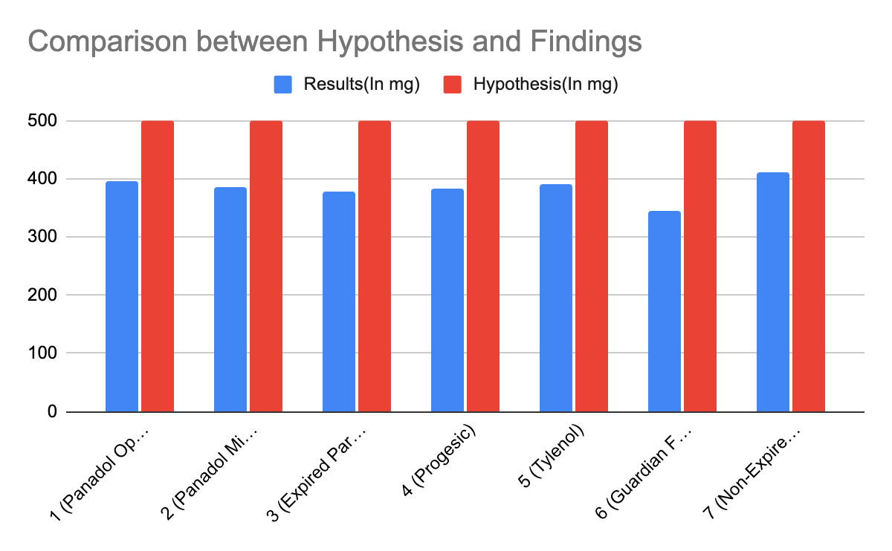

Fig 1.6: Hypothesis vs Results

**5. Conclusions**

**5.1 Summary of findings**

To summarise, our research was to ensure that the level of acetaminophen in different flu and fever tablets are at a acceptable level. To find out, we tested the hypothesis “The amount of acetaminophen in the 7 different brands of tablets should have levels not exceeding 500 mg per tablet.” and we found it to be true. Our research found that all of the pills have readings of no higher than 411mg of acetaminophen in a 500mg pill, which is below what we have expected but still renders our hypothesis true.

**5.2 Contributions of research**

This research can be linked to UN sustainability goals 3, 12 and 16, which are Good Health and Well Being, Responisble Production and Consumption, and Peace, Justice and Strong Institutions respectively. The research is trying to ensure that flu and fever tablets have an acceptable level of acetaminophen, this will thus result in responsible consumption and production of acetaminophen, and as a result, no one will be harmed due to this. In addition, these numbers can be compared with pills sold on the market and compared to see if they are real or counterfeit, as the concentration of acetaminophen would be different, if the contain acetaminophen at all. However, this test is not a substitute for rigorous testing of drugs on the market.

**5.3 Practical Applications**

Although using spectrometry has its advantages, other methods like chemical analysis should also be considered when analysing acetaminophen. However, this test does have practical applications.

For one, it is a relatively simple experiment, although it requires the usage of some harmful chemicals, such as Potassium Hexacyanoferrate(III). Nevertheless, so long as protective gloves and goggles are used, no life should be harmed. Being a relatively simple experiment, it can be used easily to monitor acetaminophen levels in over-the-counter pills and tablets.

Secondly, this research can be combined with the RSC calibration graph(RSC Education) and compared with it. It can be used to create and compare results. It can be compared with and improve on the calibration graph to create a dataset to comparison with preexisting data.

**5.4 Areas for further study**

           Further investigation into the subject matter may be done by, for example, analysing the amount of acetaminophen in liquid medicines. As this test can only be done for solid pills, a test for liquid medicines containing acetaminophen can be very helpful in constructing an overall picture of the amount of acetaminophen in medicinal products, especially ones given to children or are over-the-counter.

**6. References**

Agrawal, S., & Khazaeni, B. (2022, August 1). *Acetaminophen Toxicity*. Continuing Education Activity. Retrieved January 10, 2023, from <https://www.ncbi.nlm.nih.gov/books/NBK441917/#:~:text=Acetaminophen%20toxicity%20is%20the%20second,year%20in%20the%20United%20States>

Food and Drug Administration Philippines . (n.d.). About FDA Transparency Issuances Services FDA Advisory No. 2020-1348 || Public Health Warning Against the Purchase and Use of the following Counterfeit Drug Products: Retrieved January 11, 2023, from [https://www.fda.gov.ph/fda-advisory-no-2020-1348-public-health-warning-against-the-purchase-and-use-of-the-following-counterfeit-drug-products/ ‘](https://www.fda.gov.ph/fda-advisory-no-2020-1348-public-health-warning-against-the-purchase-and-use-of-the-following-counterfeit-drug-products/)

Haleon. (2022). *Panadol tablets*. Panadol. Retrieved February 28, 2023, from <https://www.panadol.com/en-ie/products/adult-products/everyday-pain/panadol-tablets.html>

Harvard Health Publishing. (2020, April 15). *Acetaminophen safety: Be cautious but not afraid*. Acetaminophen safe dosage basics. Retrieved January 10, 2023, from <https://www.health.harvard.edu/pain/acetaminophen-safety-be-cautious-but-not-afraid>

Prescott L. F. (2000, March 7). *Paracetamol: Past, present, and future*. American journal of therapeutics. Retrieved January 11, 2023, from <https://pubmed.ncbi.nlm.nih.gov/11319582/>

Medicines to Midnight. (n.d.). *Panadol mini caps for pain relief, paracetamol - 500 mg 48 mini caps*. Panadol Mini Caps for Pain Relief, Paracetamol - 500 mg 48 Mini Caps - Medicines to Midnight. Retrieved February 28, 2023, from <https://www.medicinestomidnight.co.nz/panadol-mini-caps-for-pain-relief-paracetamol-50-2>

RSC Education. (n.d.). *Colorimetric analysis of Paracetamol - RSC Education*. Colorimetric analysis of paracetamol. Retrieved January 27, 2023, from <https://edu.rsc.org/download?ac=12802>

U.S. Food and Drug Administration . (2022, September 6). Acetaminophen. Retrieved January 10, 2023, from <https://www.fda.gov/drugs/information-drug-class/acetaminophen>

**7. Bibliography**

Durbin, K. (2022, September 29). *Acetaminophen uses, dosage & side effects*. Drugs.com. Retrieved January 10, 2023, from https://www.drugs.com/acetaminophen.html

NPS MEDICINEWISE. (2015, May 11). *Gaps in patient knowledge*. Safe and appropriate use of paracetamol: closing the consumer knowledge gap. Retrieved January 12, 2023, from https://www.nps.org.au/news/safe-and-appropriate-use-of-paracetamol-closing-the-consumer-knowledge-gap

PHARMACOLOGY. (1975). *Acetaminophen Poisoning and Toxicity*, *55*(6), 871–876. Retrieved January 11, 2023, from https://publications.aap.org/pediatrics/article-abstract/55/6/871/51263/Acetaminophen-Poisoning-and-Toxicity.